2D Game Project

I’m planning on building upon my 2D Interactive Drawing by trying to make a very simple game utilizing the same mechanic shown in my Assignment 2 submission. I remember doing a project in high school with a similar idea, so I can probably just clone the game I made then just basically port it into the C# engine. This time though, I made the canvas 720x480 so I can go for a 720p look and also give more space for the player to click things.
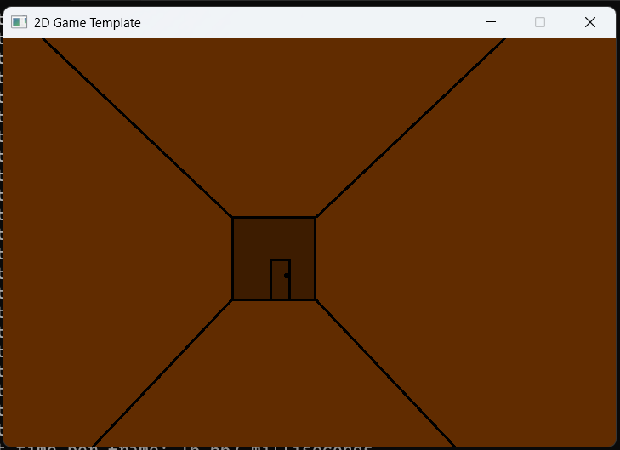
The collision aspect is something I should think about but for now, my idea for the motion is to simply animate the doors opening when you click on them. It admittedly has been a while since I last played that original game (I don’t remember if I saved it anywhere) but I remember the general idea and layout of it. Basically, it’s just a game where you’re in an abandoned spooky house and you pick up keys and open doors, and eventually once you pick up every key, you open the exit and beat the game. It’s very short but simple enough where I believe I can do it.
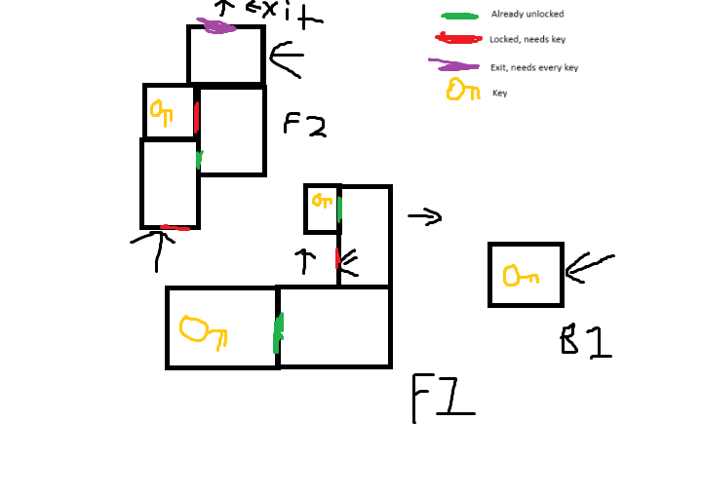
This is the map I’m planning to use for the game. I might change some things around but otherwise; it’ll pretty much be just that.
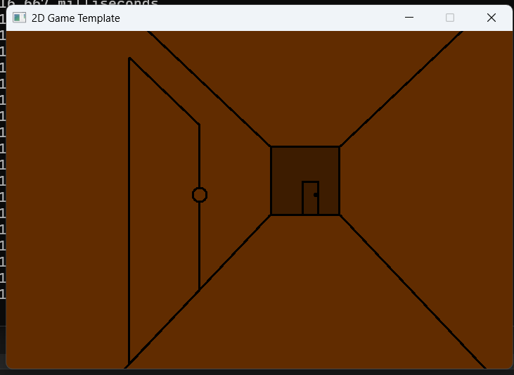
I coded in a left door texture and I’m going to add in a right door texture too. I remember that old original game had arrows to traverse through each room so I’m planning to use those.

